Finals Lab Task 7.
MySQL CRUD Operations in Python Using GUI Tkinter
Step 1. Make sure you install the necessary prerequisites:
a. MySQL-Connector in Pycharm
b. Activate xampp (Apache and Mysql)
c. Create a database named: cars
d. Import the sql file (cars.sql) to load the tables and records
Step 2. See the GUI Design of the Demo interface
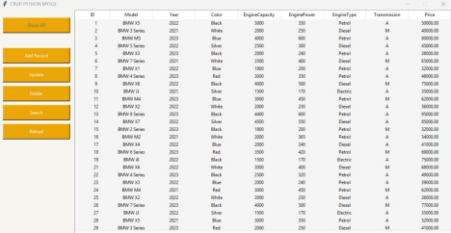Step 3. Try the code below:
Get the copy of the following files and load in pycharm:
Link here:
https://drive.google.com/drive/folders/1e6Eh55qLAwepf0A_I8GKh70elW6jAxJj?usp=sharing
1. connectDb.py
2. main.py
3. window.py
Step 4. Run the program main.py (and test all the functions (CRUD)) it should be free from errors. Make a screenshot of your output as proof that you were able to configure the program properly
Step 5. Add the ff: Functions in the GUI. Choose 1 only
1. Insert a Label and Text widget below the reload button that will display the ff: infos: a. the total Number of Records,
b. Car Model with the Highest Price,
c. Total Number of Manual
d. Total number of and Automatic Cars

